Reference: Durga software

Major difference between them is that ‘Final’ is a modifier, ‘finally’ is a block and ‘finalized’ is a method.

Final: Final is modifier and is applicable to classes, method and variables. Variable becomes constants.

Final Method: when method is declared as final then it can’t be overridden in child class.

Final Class: If final class is made final then it cannot be extended.

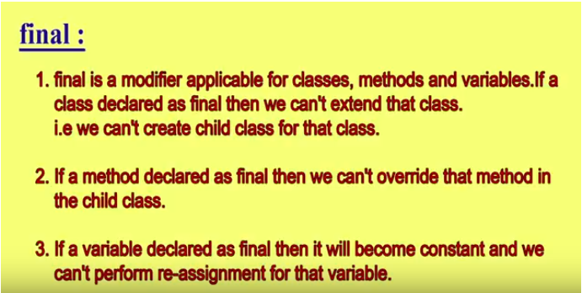

Finally: It is a block, always associated with try catch block and used to clean up activities.

Finalized: It is a method present in object class. For instance, after done with its usage, the object becomes useless then there comes the entry of garbage collector which primary function is to destroy unused objects. But before destroying the garbage collector calls ‘finalized’ function of the object to close any connections or similar stuffs (if any) associated with unused objects.